**Debugging**

1. **Status codes, description and steps to debug**

| **Status Code** | **Desc** | **Reason** | **Debug** |
| --- | --- | --- | --- |
| 400 | Bad Request | Syntax error in the request body | 1. Check request JSON body for syntax |
| 401 | Unauthorized | 1. No authorization token 2. Expired token 3. Developer changed token 4. Mistake while copy pasting token 5. Spacing mistake 6. Access restricted | 1. Check auth token |
| 403 | Forbidden | 1. When we hit a different resource path 2. When we use a diff protocol (http instead of https) 3. Diff method used | 1. Cross Check URL and end point 2. Check Token 3. Check method 4. Check everything in header 5. Check with dev if i am authorized to access the resource. 6. If everything is correct - getting error - raise a jira ticket |
| 404 | Not Found | 1. Mistake in URL - protocol/ domain name / space / wrong end point in post method 2. No proper input in variable (Global, local, env, collection) | 1. Check URL 2. Check input in variables |
| 405 | Method not allowed | 1. End point mistake 2. Incorrect method used | 1. Cross check header |
| 409 & 422 | Conflict | 1. Same resource we are trying to post repeatedly | 1. Use Random Number generator - snippet |
| 415 | Unsupported media type | 1. Trying to send request body in diff format (If API is restricted to JSON and we are trying to send request in XML/ text) | 1. Check the request body. 2. Check content type |
| 429 | Too many request | 1. Multiple req sent at a time 2. Too many body in the file sent (JSON file / CSV file) | 1. Try to send less request 2. Check how many req server can handle - if server capacity is low - raise ticket to expand server capacity |

| **Status Code** | **Desc** | **Reason** | **Debug** |
| --- | --- | --- | --- |
| 500 | Internal Server Error | 1. Resource inside a server is not triggered 2. Issue with the server | 1. Fetch logs and raise ticket in Jira |
| 502 | Bad Gateway | 1. Cookies and caches are overloaded | 1. Clear Cookies and caches - refresh -send request again |
| 503 | Service unavailable | 1. Service is under maintenance 2. When we try to fetch deleted resource 3. When features are changed | 1. Fetch logs and raise ticket in Jira |
| 504 | Gateway Timeout | 1. Server restricted for a period of time and we try to access after that   (Ex OTP expires in 10 min)  (Registration form filling timeout) | 1. Send request again complete the task within the time period |
| 599 | Network time out | 1. Slow internet | 1. Switch to diff network |

1. **Types of Logs**

* **Network logs**

Records that contains Data transfer or activities happening inside a server or network

* **System Logs**

Record of events and activities that occur within an operating system (OS) or computer system

1. **Different Ways of accessing logs**

* **Network logs**
* Fiddler tool - It is a network capturing tool or a debugging tool

Actions or requests that are happening will be captured here

Filter by URL - Filter -> URL contains (add url) -> Actions -> Run

* Inspect UI -

Open browser -> right click -> inspect / F12 -> Network (All)

Select logs except [jpeg, png]

* Post man console
* Post man -> Top left corner -> 3 dash-> View - > Developer -> Show Dev tools
* **System Logs**
* Post man -> Top left corner -> 3 dash-> View - > Developer -> View logs in explorer

**Micro Web Services Architecture**

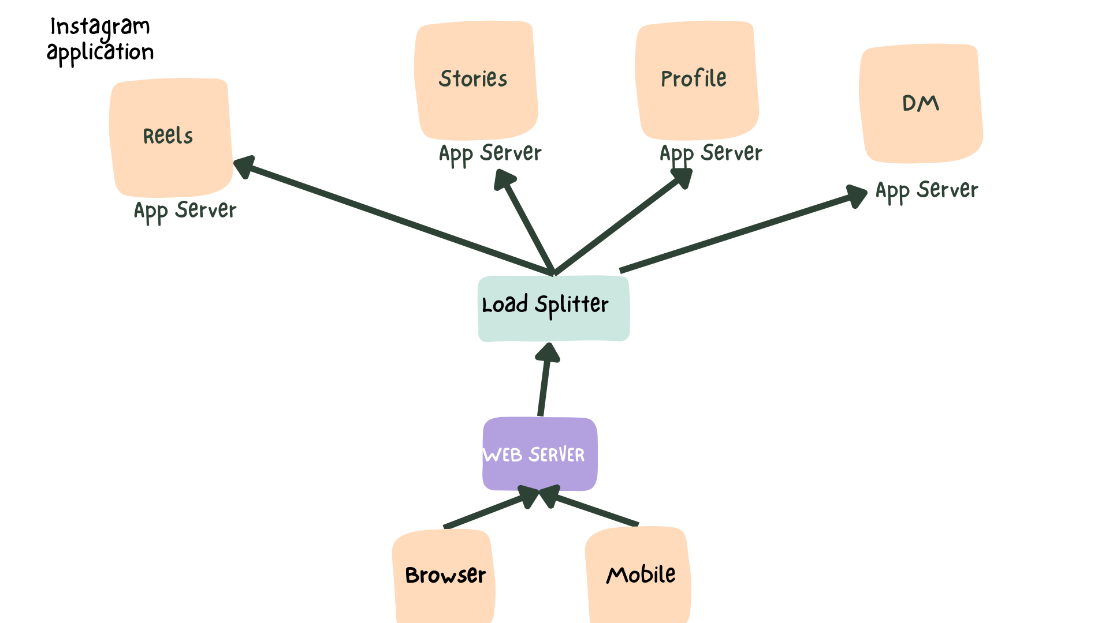

**Difference btw Web Services and Micro Services**

| **Web Services** | **Micro Web Services** |
| --- | --- |
| 1. Browser is connected to Web Server and inturn to single App server 2. Do not contain load splitter 3. Performance is low compared to micro web services 4. Increasing the server capacity is difficult if users no of users increases 5. Maintenance is low as it has only 1 server | 1. Browser is connected to Web Server and further to load splitter and in turn to multiple App server 2. Contains load splitter 3. Performance is high compared to web services. 4. Increasing the server capacity is easy even if no of users increases 5. Maintenance is high as it has multiple servers |

**Important question**

1. **How do you verify whether a defect is in the frontend or backend and which developer to report?**

* Reproduce the defect in UI, business layer and database
* If API response is correct and database is responding for the right query, but at the UI the functionality is not working -> **Report to Frontend developer**
* If functionality in UI is working correctly and the API response is not matching the API doc then -> **Report to Backend developer**
* If functionality in UI is working correctly and the API response is matching the API doc but database did not respond accordingly for the query sent then -> **Report to Backend developer**
* If we are not able to determine then fetch all relevant logs and report to the developer, they will decide which developer to resolve.